*excludes ttk except noted p10* **color codes: *explanatory*, option, example, note, syntax,**  = “results in”/"yields"

❶ **Import: from tkinter import \*** ( or **import tkinter as tk** - requires using "tk." prefix to commands)

❷ **Establish root: *root=Tk()***

❸ **Define root or toplevel Geometry:** root.Geometry(str(width)+”x”+ str

(height)+"+"+str(xoffset)+"+"+str(yoffset))*;* find screen dimensions *with* ***=root.info_screenwidth()*** *and*

***=root.infoscreenheight()****;* in TCL8.4+: **root.attributes("-fullscreen", True)**  quotes. To position root or toplevel windows use **window.lift()** or **.lower()**, or call on the window manager:

**top1.attributes("-topmost", True/False)** to hold it in place.

❹ **Create Widgets:**

❺ **Bindings** - events can bind at 4 levels: Application, Toplevel, Class, **Instance** (most common) ex: **label1.bind**("Button-1", callback function) -

 **Manual Bindings** - To respond to an event **not** auto bound to a widget, use the **.bind** method to connect a callback.

**Common Manual Bindings**

widget_name= widget_type**(**attributes/options/**command callbacks)**;

**18 Widgets (w/out ttk)**

use any callable

**Event Objects** passed to **callback**: **widget** - **<Button-1>** : leftmost button, *<1> is alias* tkinter instance; **num** - button number ; **x, y** –

Button object as a callback: **functions** (most common), bound methods, lambda expressions, Canvas commands. No **event** info is provided for inherent callbacks. A example syntax diagram:

**widget. bind (event, callback)** This binding delivers event objects to callback if a function

(* *You may need to use w.focus_set() to activate.*)

b1=Button(parent, bg= ‘light blue’, text= ‘Push me!’, command= my_callback_function) accepts it: def callback(**event**):

**Button events: always in quotes like "<1>"**

**<Button-2>** : middle button if available

**<Button-3>** : rightmost mouse button Spinbox string); **keysym** - key symbol ; **keycode** - key **<ButtonRelease-1>** : button up

**<Leave>** : mouse pointer left widget

**<B1-Motion>**: movement with button down

**<DoubleButton-1>** : double click

**<Enter>** : mouse pointer entered widget **Keyboard events:**

**<FocusIn>** : keyboard focus moved to w

**<FocusOut>** : keyboard focus moved away

**<Return>** : the keyboard enter key

**<Key>** : w.bind("<Key>", cback) any keypress

"**x**" : a letter ex: frame.bind("x", **callback**)

mouse position; **x_root**, **y_root** - mouse position

code; **other events: width, height** - new widget

size (pixels); **type** - event type **for example:**

Scrollbar relative to toplevel; **char** - character code (as a

label1.config(text=event.widget) displays name

Your widget name  option (ex: background color) function to bind when  **auto event** occurs

**widget** **type**  parent window name  option (ex: label text) *button click binding is* ***automatic***

Checkbutton

Entry

Frame

Label

LabelFrame

Listbox

Menu

Menubutton

Message

PanedWindow

Radiobutto

Scale

Text

Toplevel

# Options, values, processes, and constants

**Compass points:** 'n', 'ne', 'e', 'se', 's', 'sw', 'w', 'nw', 'center'.

**Bitmaps:** 'error', 'gray75', 'gray50', 'gray25', 'gray12', 'hourglass',

'info', 'questhead', 'question', 'warning'

**Colors:** can be given as the names of colors in the rgb.txt file (downloaded with tkinter); also hex definitions #rgb, #rrggbb, or #rrrgggbbb **Distance:** Pixels ➔ numeric**;** absolute distances ➔ strings with a trailing character denoting units: ccentimeters, i-inches, m-millimeters, p- printer’s points - these vary with font used. **Fonts:** Ex: font=("Verdana 10 bold"). Font sizes with positive numbers measured in **points**; negative numbered sizes are measured in **pixels**. **Justify:** "left", "center", "right", "fill" *include quotes*

**Region:** 4 space-delimited distances "3i 2i 4.5i 2i"

**Relief:** "raised", "sunken", "flat", "groove", "ridge"

**Wrap:** "none", "char", "word"

**Cursors:** many available such as: "arrow" "circle"

"clock" "cross" "dotbox" "exchange" "fleur" "heart"

"man" "mouse" "pirate" "plus" "shuttle" "sizing"

"spider" "spraycan" "star" "trek" "watch" **Images: B&W:** id constructor: myBWpic = tk.BitmapImage(file=myimagefile.xbm); **Color:** myphotoimage = PhotoImage(file=myimagefile. {.gif, .pgm, .ppm formats}) see pg 6&7 **Control Variables** - shared by multiple widgets, updates all users automatically: constructors are =**DoubleVar()**, =**IntVar()**, =**BooleanVar()**

=**StringVar**, **;** use: v.get(value) and v.set(value)

**Type of Events** Listed above are keyboard and mouse or pointer events. Other types of events (not detailed here) are **crossing, focus, exposure, configuration, and colormap** more on pg. 6

**Special key bindings** Cancel *(the Break key)*, BackSpace, Tab,

Return (*the Enter key)*, Shift_L *(any Shift key)*, Control_L *(any Control key)*, Alt_L *(any Alt key)*, Pause, Caps_Lock, Escape, Prior *(Page Up)*,

Next *(Page Down)*, End, Home, Left, Up, Right, Down, Print, Insert, Delete, F1, F2, F3, F4, F5, F6, F7, F8, F9, F10, F11, F12,

Num_Lock, and Scroll_Lock; *each encased in "< >"; ex: "<Tab>"*

**Other bindings: Class:** .bind_class() ex: self. Bind_class(w_type, "<event>", function) **Application:** .bind_all('<some event>', function) ex: self. bind_all('<Key-Print>', self.__printScreen)

**Using lambda to pass simple values in a binding** Ordinarily no variables are passed in an automatic binding and only event data in manual bindings. A lambda statement can be used to overcome this limitation with simple data - for example regular or control variables. Auto binding example: command=lambda: button1callback(myvar) or lambda: button1callback(cvar.get()), the callback function must specify a receiving variable container. For manual bind:

w.bind("<event>", lambda event, arg=variable: callback(event, arg)) *callback has 2 variables such as (event, myvar)*

**comments and suggestions appreciated:**

## oakey.john@yahoo.com WWW.WIKIPYTHON.COM

|  |  |  |  |  |  |  |  |
| --- | --- | --- | --- | --- | --- | --- | --- |
| **Event sequence** or event name. It is a **string** containing one or more **event patterns**, as follows: quote and angle bracket enclosure: ex: "<Key>"  " < [opt modifier(s)]… **type** [opt detail] >"  Alt, Control, Double,  like  Key or like 1, 2,  Lock, Shift, Triple Return 3or 3 | | | | | **Second Bindings** if an automatic binding is already set to a callback (using the command= callback option), another (manual) binding can be allowed to use it by including *args in the **callback** parens: callback(*args). callback will now work for both, but only the event you manually bind sends back event data and using event data causes an error if called by the automatic callback. | | |
| **Geometries: Pack, Place, Grid:** widget installation / formatting tools **Options and Attributes** | | | | | | | |
| **Geometry Options** | **Pack** | **Grid** | **Place** | **Default or**  **Requirement** | **Options** | | **Note** |
| a er |   |  |  | other window |  | | name of another window |
| anchor |   |  |   | center | compass points | | default is NW |
| before *(other)* |   |  |  | other window |  | | name of another window |
| bordermode |  |  |   | inside | outside / ignore | | border influence on slave placement |
| column |  |   |  | 0 | integer | | column number; columns start with 0 |
| columnspan |  |   |  | 1 | integer | | number of columns spanned |
| expand |   |  |  | FALSE | true/false: 0/1 | | assign more space, distribute among widgets |
| fill |   |  |  | "none" | "x", "y", "both" | | take up entire space, may need expand= |
| height |  |  |   | size | distance | | outer dimension of window plus border |
| in_= *(target)* |   |   |   | n/a | widget name | | pack inside the target widget |
| ipadx |   |   |  | 0 | distance | | internal padding pixels/distance; horizontal |
| ipady |   |   |  | 0 | distance | | internal padding pixels/distance; vertical |
| padx |   |   |  | 0 | distance | | external padding pixels/distance; horizontal |
| pady |   |   |  | 0 | distance | | external padding pixels/distance; vertical |
| relheight |  |  |   | fp | fp 0 to 1.0 | | height relative to master; modified by - height |
| relwidth |  |  |   | fp | fp 0 to 1.0 | | width relative to master; modified by - width |
| relx |  |  |   | fp % * 100 | 0.0(left)-1.0(right) | | anchor point x coordinates in master window |
| rely |  |  |   | fp % * 100 | 0.0(left)-1.0(right) | | anchor point y coordinates in master window |
| row |  |   |  | first empty | row number | | row number; rows start with 0 |
| rowspan |  |   |  | 1 | integer | | number of rows spanned |
| side |   |  |  | top / | left/ right/ bottom | | to pack against |
| s cky (glue widget to cell border) |  |   |  | centered | compass points | | W+E stretch horiz; W+E+N+S - fill all; use a **string="wens"** or **constants** =W+E+N+S |
| width |  |  |   | size | distance | | outer dimension of window **plus** border |
| x |  |  |   | 0 | distance | | anchor point x coordinate in master window |
| y |  |  |   | 0 | distance | | anchor point y coordinate in master window |
| **Methods: Universal** Geometry Methods  [**x**=widget name**.**geometry name] **b1.pack_forget() x_forget()** remove from manager but do not destroy, can reuse **ex: lab1.grid_forget()**, retrieve by repeating the original grid command **x_info()**  a dictionary of options **w.grid_info() x_slaves()** returns list of sub widgets as tkinter widget references  **x_configure(options)** *same as .pack()*  **Geometry Specific** Methods **place:** *has no other Methods.*  **pack and grid:**  **x_propagate(flag)** ; True/False; enables resizing of child widgets if too small | | | | | | **grid:**  **w.grid_bbox(column=None, row=None, col2=None, row2=None)**  **w.grid_size()** tuple with number of columns and rows **master.grid_location(x,y)**  r/c tuple with indexes **w.grid_remove()** removes widget from manager; but the widget is available for reuse  To change the following, you must call these on a widget’s **parent**: grid_**columnconfigure(**index**, options)** grid**_rowconfigure(**index**, options)**  index = column number options: minsize=, pad=, weight=, uniform= **www.wikipython.com** | |

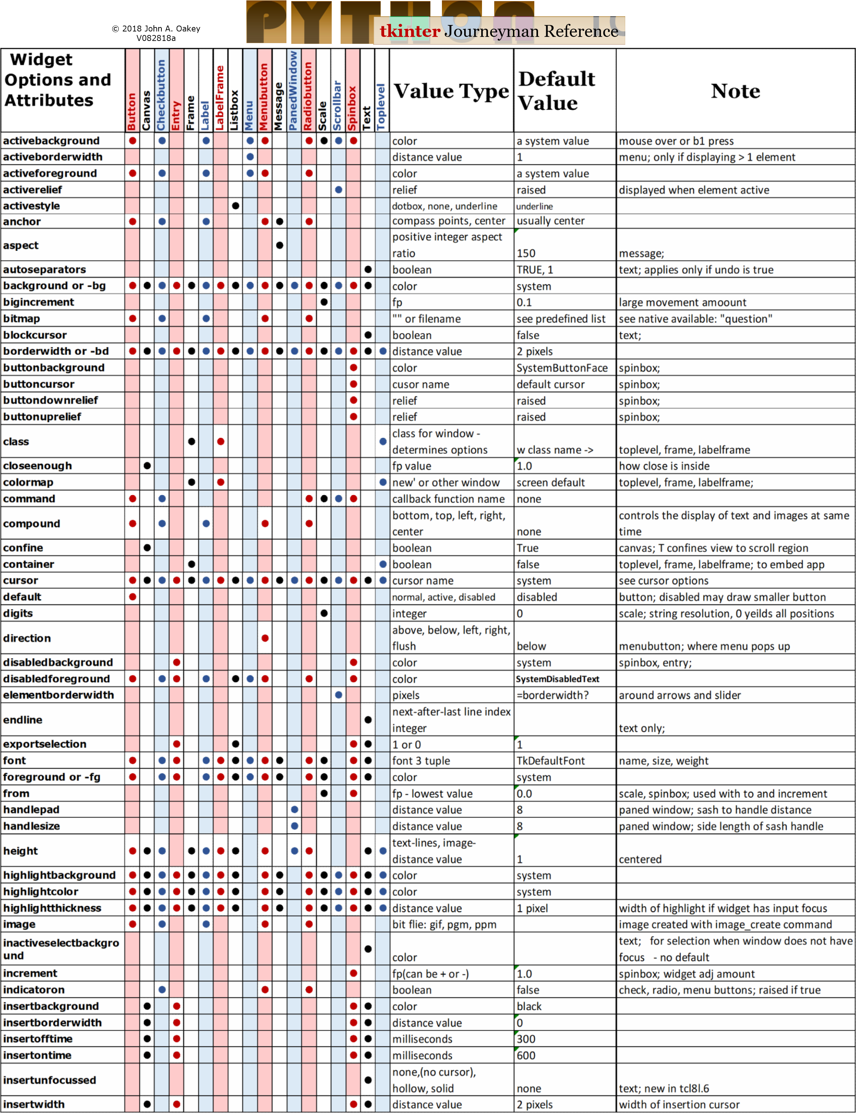

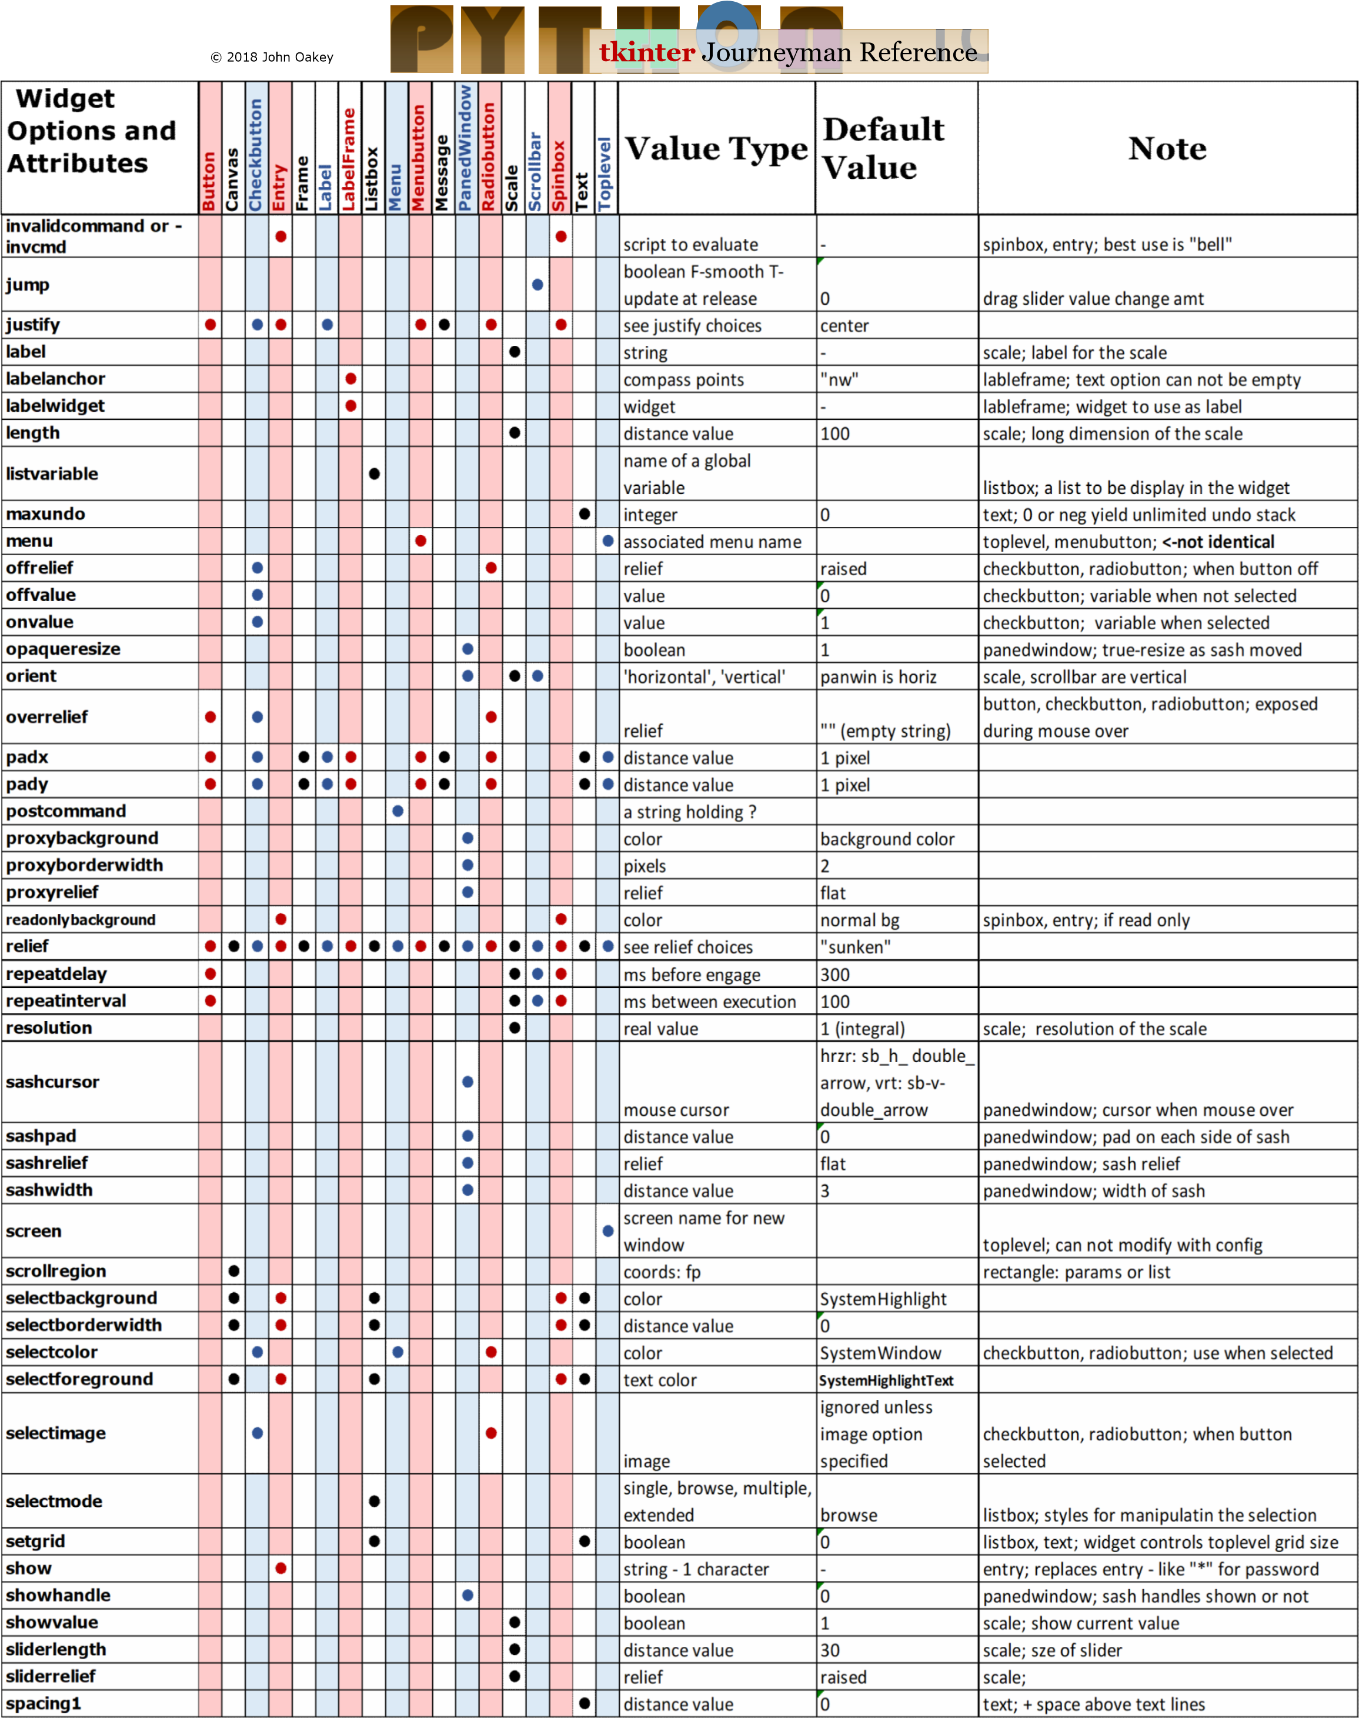

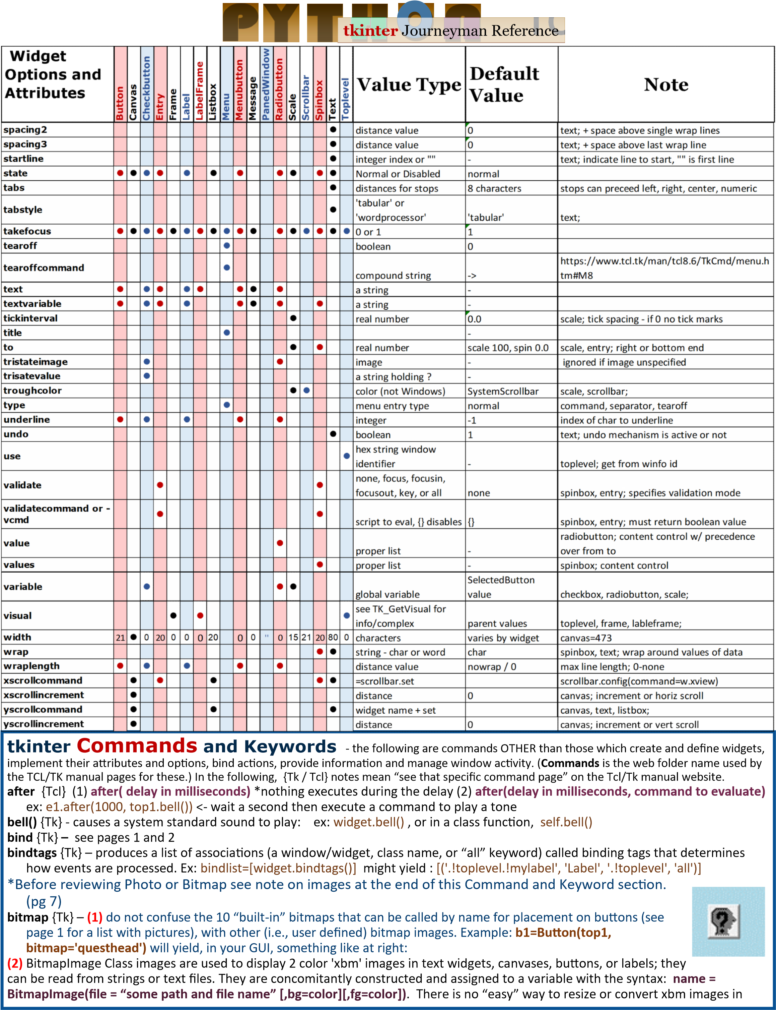

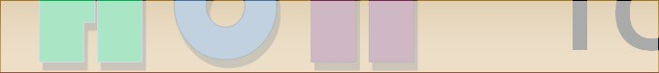**tkinter** Journeyman Reference

|  |  |  |
| --- | --- | --- |
| **tkinter Commands and Keywords cont'd**  tkinter – it must be done manually outside the program. The bitmap image variable name (holding it’s ID) is then used to display the image anywhere. For example if an image variable is created named “ini als” that is 300x86 pixels: l2= Label(top1, image=ini als, height=100, width=300) . Eliminate the height and width, and the label will be auto sized to fit the image if the label is too small.  **clipboard** {Tk} – tkinter has its own clipboard. Mul ple comments on the web give conflic ng reports about its efficacy exchanging data with various opera ng systems, but the Tk/Tcl docs do not make the claim that it does that. There are three clipboard commands for **clear()**, **append()** and **get()**. You must clear it before calling append. Examples: top1.clipboard_clear() # test clipboard - start by clearing it top1.clipboard_append("e1 is now: " + e1.get()) # put string data on the clipboard from and entry widget named "e1"  l4.configure(text=top1.clipboard_get()) # retrieve the clipboard  **colors** {Tk} – you can find a lot about colors on www.wikipyton.com. You can also find an “official” list of shortcut color names on the Tcl/Tk web site at: h ps:// www.tcl.tk/man/tcl8.6/TkCmd/colors.htm  **console** {Tk} - See: h ps://www.tcl.tk/man/tcl8.6/TkCmd/console.htm - beyond this doc’s scope.  **cursors** {Tk} -define inside configure, i.e., e1.config(cursor=”plus”); see the whole list at h ps://www.tcl.tk/man/tcl8.6/TkCmd/cursors.htm ; our favorite:  “coffee_mug” **destroy** {Tk} – deletes window and all children ex: root.destroy() – if all destroyed, normal exit occurs.  **event** {Tk} – a series of commands to manage virtual and synthesized events  **w.event_add**(“<< your new virtual event>>”, sequences)  **w.event_delete**(“<< your new virtual event>>”, sequences)  **…more…** see h ps://www.tcl.tk/man/tcl8.6/TkCmd/event.htm **focus** {Tk} – 5 Python varia ons  **w.focus_set()** – moves focus to widget w  **w.focus_displayof()** –  w with focus if it is on current display, else “None”  **w.focus_force()** – override window manager and force focus to w – not considered good programming: "impolite"  **w.focus_get()** – if your applica on is ac ve, returns w with focus, else “None”  **w.focus_las or()** – returns the widget that last had the input focus in the toplevel window that contains it  **font** {Tk} – in modern Python it is no longer necessary to load a font submodule ( Font) to change major font characterists; 12 of 18 widgets allow se ng the font it uses with a 1 to 6 item tuple in a string; usually with spaces for delimiters, for example, w.configure(font=(“Arial 8 bold italic underline overstrike”)). If we want a font name with mul ple words, a different format/ syntax is necessary, for example: w.configure(font=(“Courier New”, 12, “bold”)). Note that if you dras cally increase the font size of a widget that already holds text, the widget size may increase to fit the text displayed. **grab** {Tk} – **w.grab_set()** for example: self.top.grab_set() – where top is a toplevel window the grab command limits all ac vity to that window. **Varia ons: w.grab_current()** - if grab is in force returns iden fier, else “None”  **w.grab_release()** – end any grab in force  **w.grab_set_global()** – considered bad if not evil programming, grabs all events for everything!  **w.grab_status()** – returns ‘local’ or ‘global’ or ‘None’  **grid** {Tk} – along with **pack** and **place** these are the geometry managers and are just commands like the rest of this list.  **image** {Tk} – both bitmap and photo images are created with the constructor  **w.create_image(coords, op ons)** for op ons see below.  **keysyms** {Tk} – TK recognized list of names recognized for bindings (ex: 'space',  'exclaim', 'quotedbl', 'percent') can be found at: h ps://www.tcl.tk/man/tcl8.6/  TkCmd/keysyms.htm **li -** in the Python implementa ons, **li (aboveThis=None)** replaces Tk's "raise | **Information Methods (winfo_*x()*)**  **atom**(name (a string), displayof=0) : unique integer mapped to string  **atomname**(id, displayof=0) : mapped to id  **cells**() : # of cells in colormap **children**() : list of children **class**() : widget class **colormapfull**() : **containing**(rootx, rooty, displayof=0) : widget  @ this position **depth**() : bit depth **exists**() : true if widget exists **fpixels**(distance, ) : fp-# of screen pixels  **geometry**() : geometry sting **height**() : widget height in pixels **id**() : window identifier **interps**(displayof=0) : TCL interpreter mem list i**smapped**() : boolean; check if window created  **manager**() :geo mgr: grid,pack,place,canvas, text **name()** : widget name  **parent()** : widget parents full name **pathname**(displayof=0) : full window name of id window **pixels**(distance, ) : convert to pixels **pointerx**() : x coord of pointer on the root **pointerxy**() : xy coords of pointer on the root **pointery**() : y coord of pointer on the root **reqheight**() : min size to display widget **reqwidth**() : min size needed to display widget **rgb**(color, ) : an RGB 3 tuple - 0 to 65535 **rootx**() : left edge coord rel to screen **rooty**() : left edge coord rel to screen **screen**() : screen name as dec integer; always  ":0.0" in Windows **screencells**() : # of color cells **screendepth**() : deffault bit depth **screenheight**() : height of widget screen **screenmmheight**() : screen height in mm **screenmmwidth**() : screen width in mm **screenvisual**() : "psuedocolor" or "truecolor" **screenwidth**() : width of screen in pixels **server**() : widget screen xserver window info **toplevel**() : widget root **viewable**() : True is widget chain is mapped **visual**() : directcolor, grayscale, pseudocolor, staticcolor, staticgray, or truecolor **visualid**() : X identifier for visual this widget **visualsavailable**() : list of all visuals available for widget screen  **vrootheight**() : height of the virtual root window for widget  **vrootwidth**() : width of the virtual root window for widget **vrootx**() : x offset of virtual root relative to root window of widget screen  **vrooty**() : yoffset of virtual root relative to root window of widget screen  **width**() : widget width, pixels (update_idletasks)  **x**() : upper corner coord **y**() : upper corner coord  **ex: print(top1.winfo_children())** | |
| **More Event Types** syntax: "**<type>"**  Key  KeyRelease  Button-x, *B1-B5* ButtonRelease  Motion *<B1-Motion>*  Enter  Leave  FocusIn  FocusOut  Expose  Visibility | Destroy  Unmap  Map  Reparent  Configure  Gravity  Circulate  Property  Colormap  Activate  Deactivate  MouseWheel |
| Font size differs between platforms so no pixel to character formula is completely dependable. | |

**tkinter** Journeyman Reference

## tkinter Commands and Keywords cont'd

(aboveThis=none)" since raise is a keyword in Python.

**loadTk** {Tk} – “loads binary code from a file into the application's address space and calls an initialization procedure in the package to incorporate it into an interpreter”-far beyond the scope of this doc or the knowledge of its author. **lower(belowThis=None)** {Tk} – change a window’s posi on in the stack. “All toplevel windows may be restacked with respect to each other, whatever their rela ve path names, ***but the window manager is not obligated to strictly honor requests to restack****.*”

**op on** {Tk} – there are several varia ons of the op on command – one of which is dubious

**w.op on_add(pa ern,value,priority)** explaina on and examples by Fredrik Lundh himself in 1998 ( see: h p://e ot.org/zone/ tkinter-op on-database.htm) , one of his examples: root.op on_add("*Font", "courier"). The pa ern format is explained at h ps://www.tcl.tk/man/tcl8.6/TkCmd/op on.htm#M9 and priority values are explained by Shipman at h p://infohost.nmt.edu/ ~shipman/so /tkinter/web/universal.html; briefly priority (default=80) are 20 – global, 40 – applica ons, 60 – user files, 80-op on set up a er app ini aliza on.

**w.op on_clear()** – self descrip ve

**w.op on_readfile(**filename, priority**) –** not tested

**w.opton_get(name-instance key, className – class key) –** our team includes folks with high SAT’s, advanced degrees, and nobody who graduated below magna cum laude. A er 3 days we could not find or discover a single example of this commmand that worked. Good luck. Since all widgets support **cget()**, it would be superfluous anyway. *Comments if we are wrong appreciated*. **op ons** {Tk} – see standard op ons list: h ps://www.tcl.tk/man/tcl8.6/TkCmd/op ons.htm **photo** {Tk} – pic2=pic.subsample(6,6) A full color image; currently the **PhotoImage** class reads only **GIF, PGM, and PPM**. Use **Pillow** (Imaging Library) to work with other image types. **"Pillow" replaces the "Python Image Library" in *modern* Python.** PhotoImage objects are simultaneously created and assigned a variable name with a command in the form **v=PhotoImage(file=”file loca on and name”)**, ex: myphoto=PhotoImage(file=”C:\BigSelfie.gif”) or PhotoImage can read encoded GIF files from strings. Keep a reference to your image stored in a global variable. Images are displayed with the **create_image** command. There are useful methods associated with photo object instances sca ered across the web – the most concise collecton is Lundh’s 1998 book in pdf form, page 112, which can be found at h ps://users. tricity.wsu.edu/~bobl/cpts481/an-introduc on-to-tkinter.pdf. Included are **configure(), cget(), width(), height(), type(), get(x,y), put(data), put(data,bbox), read(), write(), blank(), copy(), zoom (xscale,yscale), zoom(scale), subsample(xscale, yscale), and subsample (scale).**

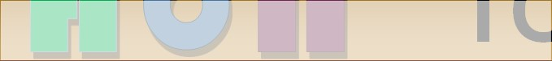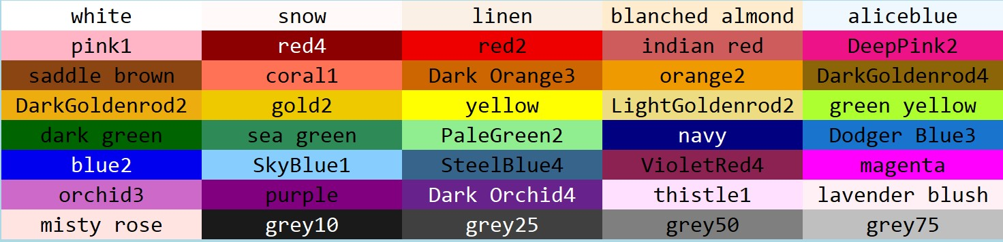

S

o

m

e

H

a

n

d

y

C

o

l

o

r

N

a

m

e

s

**raise** {Tk} – RAISE DOES NOT EXIST in the Python implementa on; the subs tuted command is **“li (aboveThis=None)”** – see **lower() selec on** {Tk} – implements the full selec on func onality described in the X Inter-Client Communica on Conven ons Manual (ICCCM). This includes **selec on_clear(), _get(), _handle(command), _own(), _own_get()**.

**send** {Tk} – execute a command in a different applica on – see h ps://www.tcl.tk/man/tcl8.6/TkCmd/send.htm **update()** – force process of all pending events, can be used to force response to user inputs. **update_idletasks()** – processes only display and window calcula ons – does not allow new events

**Note on images:** (see **bitmap** and **photo**) tkinter na vely handles two kinds of images, they are a (1) PhotoImage – full color - (GIF, PGM, PPM) or a (2) BitmapImage -monochrome X11 files - with the extension “.xbm”. The command to display images is:

**widgetname.create_image(posi on given by x, y; **other op ons )**. The **other op ons** are: ac veimage=, anchor=, disabledimage=, **image= (the object),** state= (normal, disabled, hidden), or tags=. The command returns the item id which can be used wherever an image object is needed.

## Other Modules Supporting tkinter:  means see discussion on www.wikipython.com

 **scrolledtext** - text widget + scrollbar, works similar to message  **colorchooser** - very Windows similar, tricky, not well documented online **commondialong** - baseclass for other dialogs below

 **filedialog** - handle file open and save interface - like Windows dialog

 **fontchooser** - designate font - good demo hard to find

 **messagebox** - standard (limited) message function - very similar to windows - OK, YES, NO , CANCEL, unfortunately not always well behaved but it can be tamed

 **simpledialog** - basic dialogs and convenience functions: one item input: strings, integers, floating point **turtle** - use turtle graphics in a tkinter environment **dnd** - *experimental! - drag-and drop support

Note these are **modules** that must be imported - they do not come in automatically when importing tkinter. See the top of pg 10 for a scrolledtext example.

**Running the Color Utility Color Chooser:**

from tkinter import colorchooser colorchooser.askcolor(initialcolor=

'#ff0000')

Please send comments/suggestions to oakey.john@yahoo.com

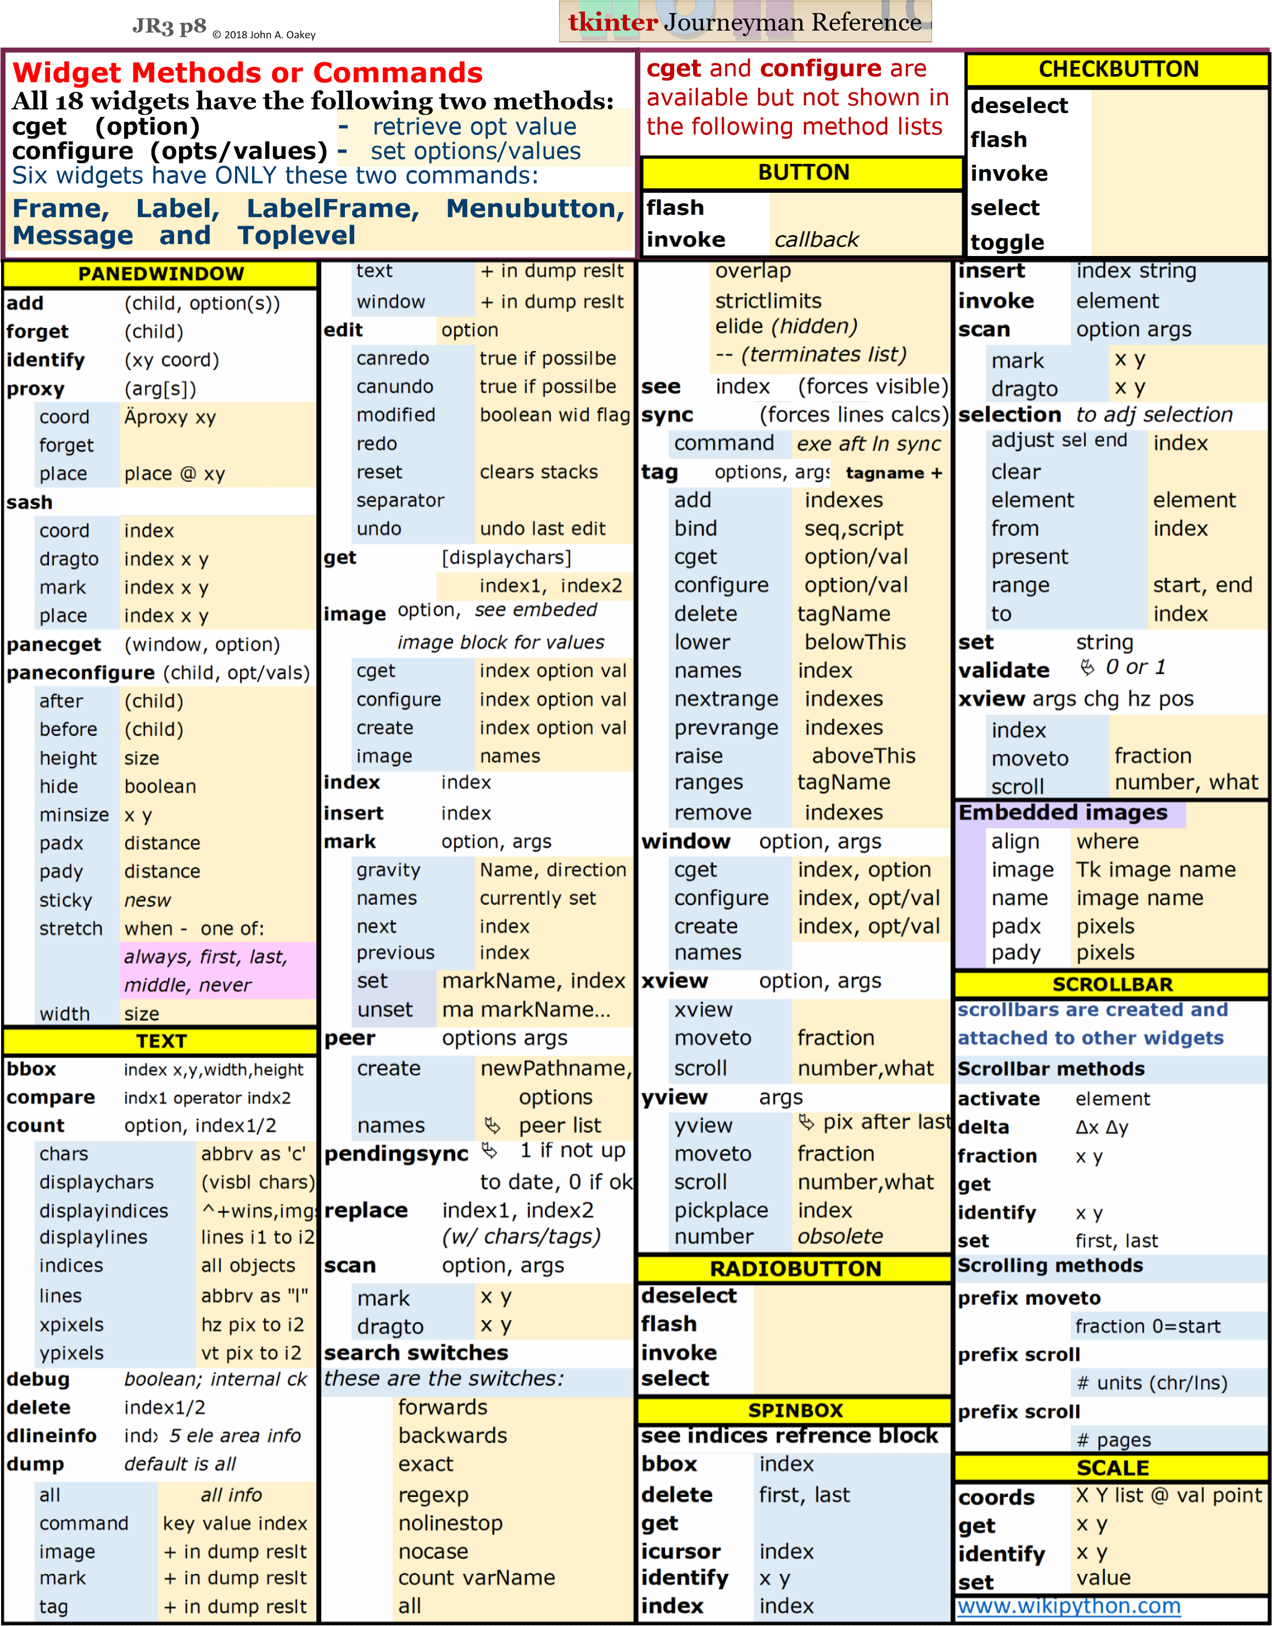

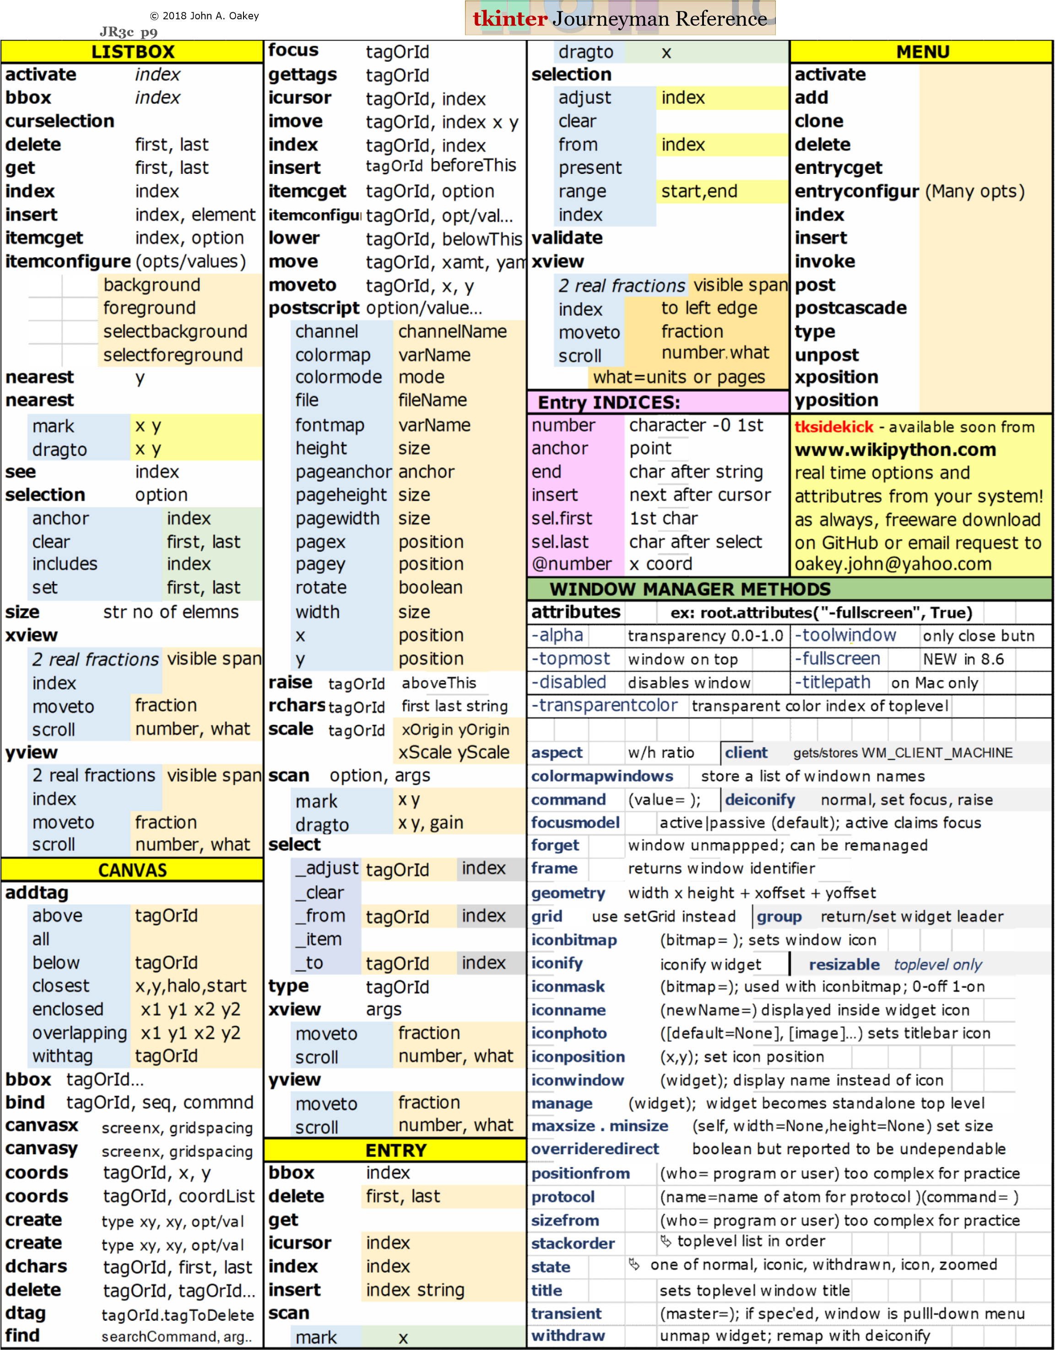

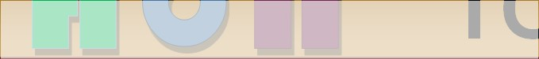 **JR3dp10**© 2018 John A. Oakey **tkinter** Journeyman Reference

|  |
| --- |
| **Scrolled Text Widget** one of the separate tkinter.scrolledtext modules: constructed like a Text widget but has a text widget and a vertical scroll bar packed in a frame. Special Attributes: ScrolledText.frame, and Scrolledtext.vbar  **To import: To use:** (example assumes a butt-load of text in a variable called "testtext") from tkinter import * st= tkinter.scrolledtext.ScrolledText(top1, width=50, wrap=WORD, height=8) import tkinter.scrolledtext st.grid(row=1, column=1) *(test header on www.wikipyton.com* st.insert(INSERT, testtext)  *will be useful for trying this)* See the example and get useful Latin text filler for testing on www.wikipython.com |

ttk was a major optional addition to tkinter. It reduces the options available adding ttk per widget by employing STYLES and THEMES. A widget's style is either the

value of its style configuration option or the default for the widget defined by

|  |  |
| --- | --- |
| **Replaced** | **Added** |
| Button | Combobox*1 |
| Checkbutton | Notebook |
| Entry | Progressbar |
| Radiobutton | Sizegrip |
| Menubutton | Seperator |
| Scale | Treeview |
| Label | **Unaffected** |
| LabelFrame | Text |
| Frame | Spinbox |
| PanedWindow | Listbox |
| Scrollbar | Message |
|  | Toplevel |
|  | Canvas |
|  |  |

|  |
| --- |
| **To import ttk:**  from tkinter import * from tkinter.ttk import* root=Tk() |

it's class. Usually the style is "T" + the class, i.e., TButton. The exception is "Treeview", not "TTreeview". A widget is made up of elements. A **style** defines a widget's elements and how they are laid out. Each element may have multiple options. Options can be different in every theme. Every widget class has a **Style()**. **THEMES** are a collection of similar styles. Stock ttk **themes** are: **winnative, clam, alt, default, classic, Vista, xpnative.** ttk replaces some tkinter widgets, has no effect on another group of tkinter widgets, and adds six brand new widgets of it own, see table: One purpose of ttk is to simplify code by separating methods and attributes and "automating" attributes with **styles** emulating existing platforms, or at least to provide a consistent appearance. Python has a fair, if sometimes misleading, ttk summary at:

https://docs.python.org/3/library/tkinter.ttk.html and **most** of the following is summarized from there.

**To Use a Theme: (winnative, calm, alt, default, classic, Vista, xpnative)** style=Style()

style.theme_use("themename")

**To Configure a style:**  fg & bg not supported 

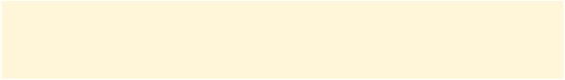

style.configure("myStyleName", foreground="red", background="blue") **Universal Standard ttk Widget Options:**

class (read only for option values), cursor (default is inherited), takefocus (in traversal: 0,1, or “”), style (to specify custom style)

**Scrollable Widget Options:** xscrollcommand, yscrollcommand – *use Scrollbar.set()*

**Label Options:** text, textvariable, underline, image, compound, width **Universal Standard ttk Widget Methods:** Tkinter.Widget.cget(), tkinter.Widget.configure(), class tkinter.ttk.Widget: identify(x,y), instate (*statespec*, callback=None, *args, **kw), state(*statespec=None*)

|  |
| --- |
| *1 tip: get value change bind **"<<ComboboxSelected>>"** |

**Widget States:**

active, disabled, focus, pressed, selected, background, readonly, alternate, invalid **Style:** is a class used to manipulate the style database and supports the following

|  |  |  |
| --- | --- | --- |
| **configure**(style, query_opt= None, **kw) | **map**(style, query_opt=None, **kw) | **lookup** (style, option, state=None, default=None) |
| **theme_create** (themename, parent= None, settings=None) | **theme_names() theme_use** (themename=None) **theme_settings** (*themename*, settings) | **element_options** (elementname) **element_names()** |
| **element_create** (elementname, etype="image", or "from", *args, **kw= border, height, padding, sticky, and/or width) | | |
| **layout** (*style*, *layoutspec=None*) (None, side:whichside, sticky:nsew, unit: 0 or 1, children:[sublayout…] | | |

|  |
| --- |
| Big Daddy's Python Toolbox, wikipython, and tkinter  Journeyman Reference are all copyright 2017 by John A. Oakey.; oakey.john@yahoo.com; materials may be duplicated for school and personal reference. Enjoy! |

what about tix? *Deprecated since version 3.6:*

This Tk extension is unmaintained and should not be used in new code. Use tkinter.ttk instead.